
© Copyright 2020 Morpho Detection, LLC
7151 Gateway Boulevard, Newark, CA 94560 USA Tel: 510.739.2400
Fax: 510.739.6400

Title: EDS Inspection Removal Script Instruction

Document number: N/A
Affected systems: N/A
Originator: Sean Yu
Revision date: 4/24/2026

Disclaimer:
IMPORTANT – USE AT YOUR OWN RISK
The tool [del_insp] is provided free of charge and is licensed under the MIT License included with this package.
It is supplied "AS IS" without any warranty, express or implied. I have tested it to the best of my ability on lab and selected production environment, but I cannot guarantee it will work in your environment or that it will not cause damage.
You are responsible for:
- Testing the tool thoroughly in a non-production system that mirrors your production environment
- Backing up any data before use
- Determining suitability for your purpose
In no event will Smiths Detection or the author be liable for any direct, indirect, incidental, or consequential damages arising from use of this software, even if advised of the possibility of such damage.
By running the binary you acknowledge you have read this notice and accept these terms.

Introduction

This procedure describe the steps to prepare and run a script to detect available inspections from MUXed and standalone CTXs and provide option to remove unused inspections.

References
  - xxxxxxx
  - Postman User manual

Definitions
  - CI Control Interface Computer
  - TRI User Interface Computer
  - PTRI User Interface Computer
  - Host CTX Host computer
  - RAIN MUX server
  - FSE workstation Service monitor and keyboard located on output left side of CTX

Tools & Supplies
  - USB Flash Drive
  - Laptop

Procedure

- Prepare USB Flash Drive

- Verify USB flash drive file system.
- This can be done by plugging the USB flash drive into a laptop or desktop PC running Windows. Right click on USB flash drive icon in File Explorer and choose Properties. USB flash drive formatted as NTFS can run script directly on USB drive. File systems such as FAT32 or ExFAT require copying the script file to target computer and permission adjusted (See step 6 and 7).
- Obtain script file or zip package from Smiths Tech Support. For zip package, extract content and copy only the script file (del_insp) to USB flash drive
- When copying the script file to USB flash drive, it is usually copied to root or the top most level of USB drive file system. However should you decide to create a folder and store the extracted script file under this folder, then adjust the script path in the next section accordingly.

- inspection removal

- Identify which target computer can be used to run the script file. This could either be CTX Host computer, one of TRI/PTRI/CI computers or MUX Rain servers
- Login into target computer as lowercase geeds and open a terminal window
- Plug USB flash drive into target computer
- At terminal $ prompt, type the following command to find out where USB drive is mounted and make a note of USB flash name i.e. KINGSTON:

$ lsblk

- At terminal $ prompt, change working directory to USB drive (example below assume USB drive is mounted at /run/media/geeds/KINGSTON/ per previous step):

$ cd /run/media/geeds/KINGSTON/

- Copy script file from USB flash drive to target computer. (The step below assume script file is at the root or top most level of USB drive file system. If the script is under a folder, please insert the folder name between USB flash drive and the script name. For example: cp /run/media/geeds/KINGSTON/foldername/del_insp /home/mdi/)

$ cp /run/media/geeds/KINGSTON/del_insp /home/mdi/

- Change script file permission:

$ cd /home/mdi/ && chmod +x del_insp

- At terminal $ prompt, execute the script file and follow onscreen prompt:

$ ./del_insp

- Identify the line number corresponding to target CTX and its inspection to be removed.
- Enter line number and press ENTER key to confirm selection. At the next prompt, enter 'y' to confirm deletion and press ENTER to start deletion.
- Verify after the list refresh that the inspection has been removed. At anytime, press "Ctrl+C" or 'q' to exit.
- Each CTX should have only one active inspection installed (HDE or HDEC). If the drop down list shows only one inspection available, do not remove that inspection otherwise machine will not operate properly!
- Special Usage:
- d#: press 'd' follow by line number to remove orphaned database entry.
- r#: press 'r' follow by line number to remove orphaned rpm package.
- f#: press 'f' follow by line number to fix remote host ssh key error and wait for refresh.

- When done, exit script (press "Ctrl+C" or 'q' to exit)
- Unmount USB flash drive:
$ cd && umount /run/media/geeds/KINGSTON
- Unplug USB flash drive.
- Reboot CTX Host computer
- Log off and log back into CI. Confirm on CI that HDE option is now gone and HDEC and IQ are the only Inspections avaiable.
- Perform RTS level 2
- Document the work performed for future reference.

- Sample screenshot
MUX
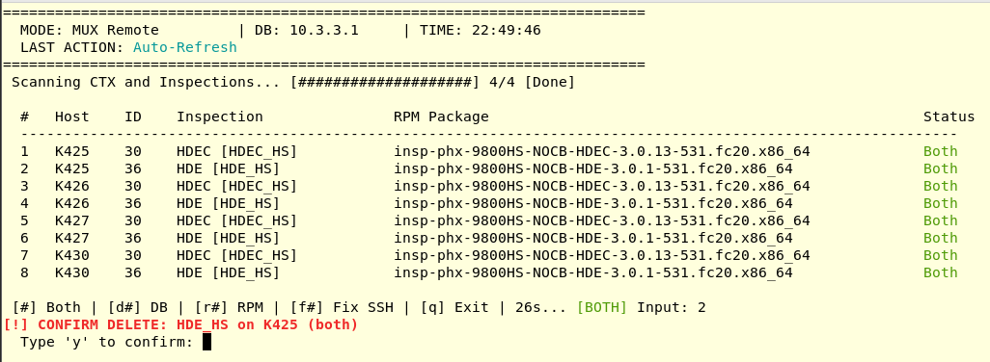

Standalone
